Topology Graph
# Source: Chatgpt (GPT‑5 Mini) at [12/14/2025]
A topology graph is a visual representation of how devices in a computer network are arranged and connected. It helps network administrators understand how data flows, identify network layout, and plan or troubleshoot infrastructure.

🧠 Simple Definition:
# Source: Chatgpt (GPT‑5 Mini) at [12/14/2025]
A topology graph shows network nodes (like routers, switches, servers) and the connections (links) between them.

📊 Common Elements in a Topology Graph:
# Source: Chatgpt (GPT‑5 Mini) at [12/14/2025]
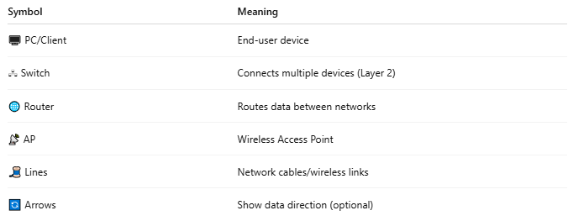
Symbol | Meaning
🖥️ PC/Client | End-user device
🖧 Switch | Connects multiple devices (Layer 2)
🌐 Router | Routes data between networks
📡 AP | Wireless Access Point
🧵 Lines | Network cables/wireless links
🔄 Arrows | Show data direction (optional)

🗺️ Types of Network Topologies (Represented in Graphs)
# Source: Chatgpt (GPT‑5 Mini) at [12/14/2025]
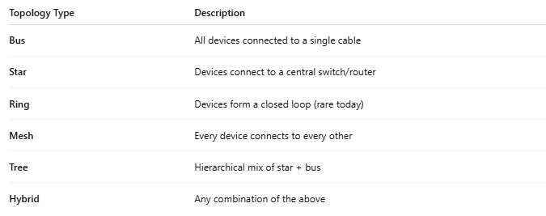
Topology Type | Description
Bus | All devices connected to a single cable
Star | Devices connect to a central switch/router
Ring | Devices form a closed loop (rare today)
Mesh | Every device connects to every other
Tree | Hierarchical mix of star + bus
Hybrid | Any combination of the above

🧭 Example: Simple Star Topology Graph
# Source: Chatgpt (GPT‑5 Mini) at [12/14/2025]
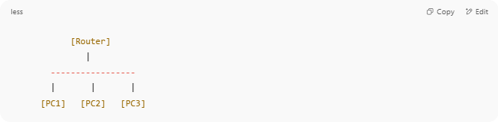
[Router]
|
-----------------
| | |
[PC1] [PC2] [PC3]

Each PC is connected to a central device (Router/Switch).

🎯 Why It Matters
# Source: Chatgpt (GPT‑5 Mini) at [12/14/2025]
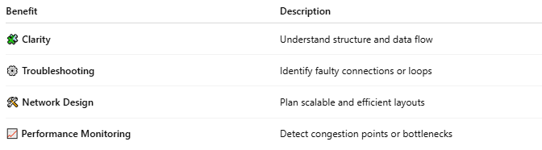
Benefit | Description
🧩 Clarity | Understand structure and data flow
⚙️ Troubleshooting | Identify faulty connections or loops
🛠️ Network Design | Plan scalable and efficient layouts
📈 Performance Monitoring | Detect congestion points or bottlenecks

✅ Summary
# Source: Chatgpt (GPT‑5 Mini) at [12/14/2025]
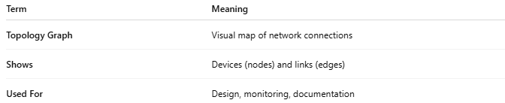

Term | Meaning
Topology Graph | Visual map of network connections
Shows | Devices (nodes) and links (edges)
Used For | Design, monitoring, documentation

